**NAAN MUDALVAN ASSIGNMENT**

**NAME:** SATHISH KUMAR R

**DEPARTMENT**: BE ELECTRICAL AND ELECTRONICS ENGINEERING

**COLLEGE**: 8110 IMAYAM COLLEGE OF ENGINEERING

**NAANMUDHALVAN COURSE**: DIGITAL MARKETING

**NM ID**: CB37CE428363F7FA03E46C66704052FB

ASSIGNMENT 1:

Create a blog or website using Blogspot and word press. Customize the theme design and post new article with 500 words.

URL: https://saisports50.blogspot.com/2023/10/welcome-to-sai-sports.html

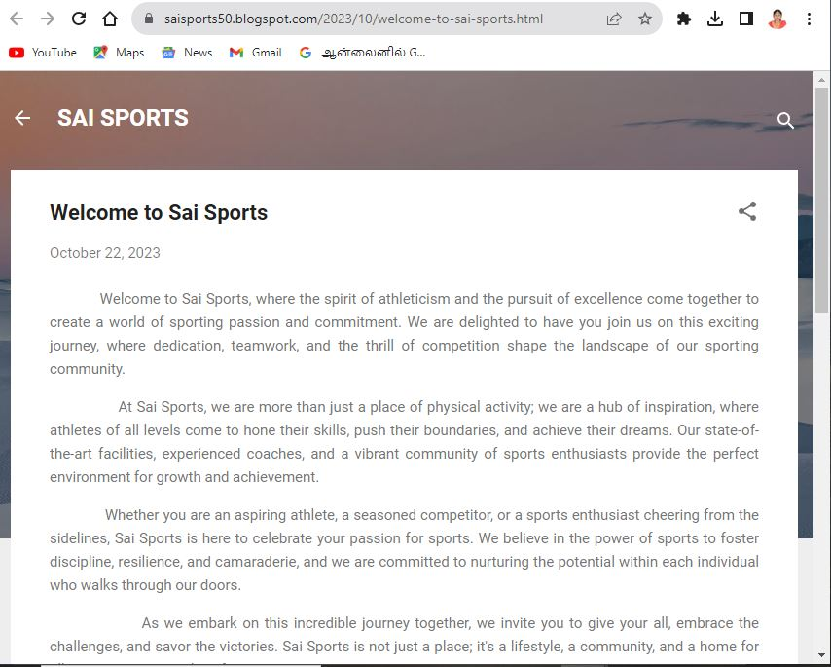

ASSIGNMENT 2:

Create a new Facebook business page and post one social media poster for your brand.

URL: <https://www.facebook.com/profile.php?id=61551988871182>

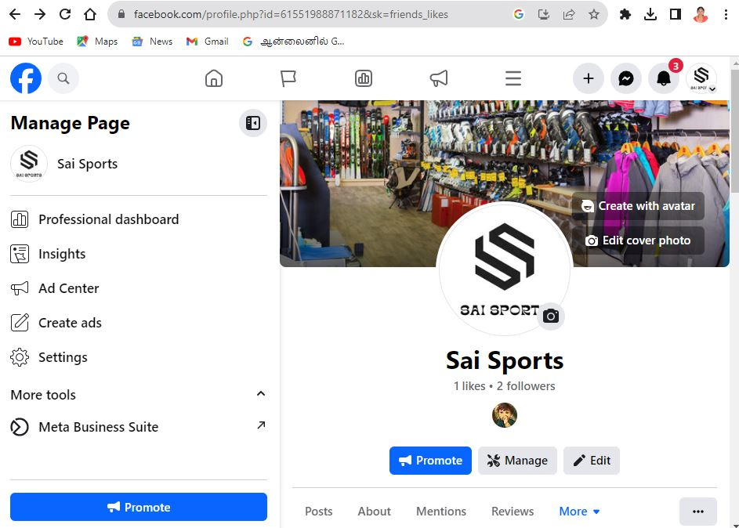

ASSIGNMENT 3:

Create and design a advertisement poster using Canva.

URL: https://www.facebook.com/profile.php?id=61551988871182

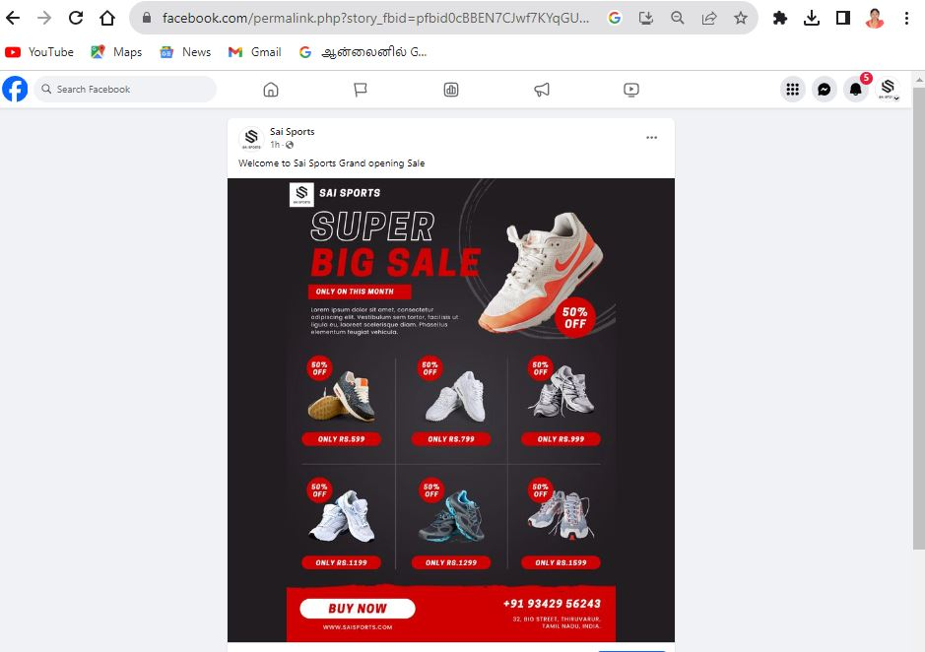

ASSIGNMENT 4:

Create an E mail newsletter design using Mailchimp or Canva tool.

URL: <https://saisports50.blogspot.com/2023/10/email-newsletter.html>

